REGISTRATION FORM OF 13th GCBSS CONFERENCE 2022

17-18 June 2022
Grand Millennium Kuala Lumpur (5-STAR), Malaysia
(IN-PERSON & ONLINE)
http://gcbss.org/CIMSSR2022/Registration-Payment.html

13th GCBSS will be held during 17-18 June 2022 Grand Millennium Kuala Lumpur (5-STAR), Malaysia (In-Person & Online). Please note that it is essential for all participants to email the filled Registration Form (.doc/.docx/pdf) along with Proof of payment receipt to ids: admin@gcbss.org and Cc to register@gatrenterprise.com

SECTION 1: CONTACT INFORMATION
Paper ID Code: For example, CIMSSR-00101
Name that you would like to get printed on the certificate:

Conference Title: 13th Global Conference on Business and Social Science, Kuala Lumpur, Malaysia.
Whether attend the Conference: € Yes € No
Position (Professor/Associate Prof/Assistant Professor/Lecturer/PhD Student/Master Student/other):

Full Affiliation/Organization/University and country Name:
(that you like get printed on the certificate)

Broad Field: i.e. Accounting |  | Are you willing to serve as a session chair:€ Yes € No
Session Type:€ Oral Presenter € Poster € 3 Minutes PhD proposal € Visual Presenter (ZOOM)
Telephone: | Mobile: |  | Email:
Special Needs or Dietary Requirements: € Yes €No
Fulltime Student ID Number of Your University (if applicable):
Abstract/Paper Title:
Paper Pages: |  | Additional Page:
Are you interested to join Conference Tour: € Yes € No
Are you interested to attend GALA Dinner & Networking: € Yes € No
Are you interested to attend Workshop: € Yes € No
Are you interested to join Academic Discussion Session: € Yes € No

Notes:
- One regular registration can cover a paper within 8 pages, including all figures, tables, and references at 1.5 line spacing. If the length exceeds 8 pages the authors are required to pay USD 25.00 for each additional page.

- If number of authors are more than two in manuscript authors are required to pay additional fees USD 50 for each additional author name.

- For additional Certificates for co-authors needs to pay USD 100 for each additional certificate.

SECTION 2: REGISTRATION FEESINFORMATION

13TH GCBSS FEE SCHEDULE: | Early bird  Until:  21/02/2022 | Normal  Until:  30/04/2022 | Late  Until: 13/06/2022
Oral/Poster Presenter (Lead Author) / Co-author | USD 525 | USD 575 | USD 600
Visual Presenter (Through ZOOM) | USD 525 USD 425 | USD 575 USD 475 | USD 600 USD 500
Full Time Student (Valid student ID required) | USD 425 | USD 475 | USD 500
Additional Paper (by same Presenter) | USD 425 | USD 475 | USD 500
Attendee (Without abstract/Paper) | USD 225 | USD 250 | USD 275
Online Attendee (Without abstract/Paper) (Through ZOOM) | USD 100 | USD 100 | USD 100
Additional Events for 13th GCBSS Delegates:
Academic Discussion Session on 17June 2022 | FREE | FREE | FREE
Workshop on Publishing in High Impact Factor (SSCI & SCI) Indexed Journals on 18 June 2022 | FREE | FREE | FREE
GALA Dinner & Networking on 17 June 2022 | FREE | FREE | FREE

GATR/GCBSS Policy:

- The lecturer cum student will not be considered for the student rate.
- A full-time student must need to submit a valid student ID card and letter of recommendation from Dean.
- Daily Market Conversion Rate is applicable to all USD prices.
- Service/Transfer Fees are not included in the above prices.

Registration fee of Oral/Poster/ Student Presenter Included:

Admission to the welcome reception and all session

- Academic Discussion Session
- Conference KIT
- Printed presenter certificate with official seal
- Printed brief program Schedule
- Refereed Abstract Proceeding CD with ISBN
- Journal publication fees (Sponsored by GATR)
- Workshop on Publishing in SSCI & SCI Journals
- Two coffee breaks each day
- International Buffet lunch daily
- GALA Dinner& Networking

Registration fee of Visual/Online Presenter Included:

Admission to the welcome reception and all session

Free Courier of KIT (All Countries)
- Conference KIT
- Printed presenter certificate with official seal
- Refereed Proceeding CD with ISBN
- Abstract Video publication on Official Channel
- Journal publication fees (Sponsored by GATR)
- Printed program Schedule
- Workshop on Publishing in SSCI & SCI Journals Material & CD
- Best Presenter Certificate

Registration fee of Attendee Included:

Admission to all session

- Participation Certificate with official seal
- Refereed Proceeding CD with ISBN
- Program Schedule
- Workshop on Publishing in SSCI & SCI Journals Material & CD
- Best Presenter Certificate

SECTION 3: PAYMENT INFORMATION

OPTION 1

Bank Deposit / ATM Transfer / Online Transfer / Telegraphic Transfer in Company official account.

Please Visit: http://gcbss.org/CIMSSR2022/Registration-Payment.html
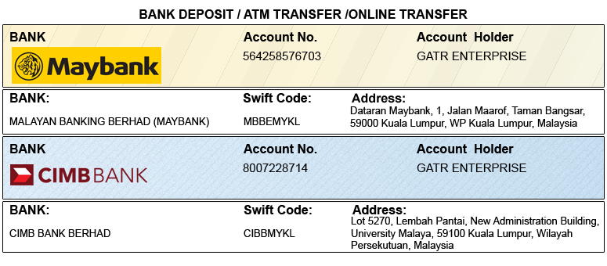

OPTION 2

Credit Card /Debit Card/PayPal/2Checkout Account to GATR 2checkout official account. Registered email: info@gatrenterprise.com

Please visit: http://gcbss.org/CIMSSR2022/Registration-Payment.html
Note: Please mention your Abstract Id in particulars to trace your payment. 5% Transaction Charges will be applied for payment through credit card.

PRIVACY POLICY:

The Global Academy of Training & Research (GATR) Division will protect your personal information. Your personal information received will only be used to fill your order. We will not sell or redistribute your information to anyone.

CANCELLATION POLICY:

You may cancel without penalty if written cancellation request is received up to and including 45 days prior to the start of the conference. A credit voucher less 50% of the registration fee will be issued for written requests received up to and including 25 days prior to the start of the conference. No refunds or credits will be issued on cancellation requests received less than 25 days prior to the start of the event. No liability is assumed by Global Conference on Business and Social Science for changes in program, date, content, speakers or venue.

PLEASE NOTE: Original receipts will be emailed to register guest before conference for claim purposes.
Declaration: I agree that I cannot claim back the registration fee I paid under any circumstance.
SIGNED:  (or write name here) |  | DATE:

